
TRIBHUVAN UNIVERSITY
INSTITUTE OF HUMANITIES AND SOCIAL SCIENCE
MADAN BHANDARI MEMORIAL COLLEGE (MBMC),
ANAMNAGAR, KATHMANDU

A Project Proposal On
Library Management System

Submitted To:
DEPARTMENT OF HUMANITIES AND SOCIAL SCIENCE
TRIBHUVAN UNIVRESITY (T.U),
KRITIPUR, KATHMANDU, BAGMATI, NEPAL

In partial fulfilment of the requirements for the degree of Bachelor’s in COMPUTER APPLICATION (BCA)

Submitted By:
SRIJANA SUBEDI (43202149)
ROJ DAHAL (43202141)

Under the supervision of
Mr. Prakash Subedi
Table of Contents
Table of Content……………………………….……………………………….…...……i

ABBERIVATION iii
List of Figure iv
List of Table………………………………………………………………………………v
Chapter 1: Introduction 1
1.1 Introduction 1
1.2Problem Statement 2
1.3Objectives 3
1.4 Scopes and Limitation 4
Chapter 2: Background Study and Literature Review 5
2.1BackgroundStudy……………………………………………………………………..5
2.2Literature Review…………………………………………………………………….6
Chapter 3: System Analysis and Design 7
3.1 System Analysis 7
3.1.1 Requirement Analysis 7
i Functional Requirements 9
ii Non Functional Requirements 11
iii Technical Requirement..……………………………………………….
3.1.2 Feasibility Analysis 11
i Technical Feasibility…………………………………………………..10
ii Operational Feasibility………………………………………………10
iii Economic Feasibility………………………………………...……….11.
iv Schedule……………………………………………………….………11
3.1.3 Data Modelling (ER-Diagram)…………….………………………12.
3.1.4 Process Modeling(DFD)……………………………………………12.
3.2 System Design………………………………………...………………………13
3.2.1 Architectural Design……………………….……………………………13
3.2.2 Database Schema Design………………….……………………………13
3.2.3 Interface Design…………………………..……………………………14
Chapter 4: Implemantation and Testing………………………………………………15 4.1 Implemantation……………………………..………………………………………15
4.1.1 Tools Used………………………………………………………………16
4.2 Testing………………………………………….……………………………17
4.2.1Test Case for Unit Testing………………………………………………18
4.2.2 Test Case for System Testing…………………………………………18
Chapter 5: Conclusion and Future Recommendation………………………………20
5.1 Outcomes……………………………………………………………………20
5.2 Conclusion…………………………………………………………………..20
5.3 Future Recommendation……………………………………………………21
Appendices…………………………………………………………………………….22
References……………………………………………………………………………….25

ABBERIVATION

LMS: Library Management System
PHP: Hypertext Preprocessor
MYSQL: My Structured Query Language
S.W.O.T: Strength, Weakness, Opportunities, Threats
ROT: Return on investment
ER: Entity Relationship
DFD: Data Flow Diagram
HTML: Hypertext Markup Language
CSS: Cascading Style Sheets
RFID: Radio Frequency Identification
AI: Artificial Intelligence

List of Figures
Figure 1 Agile Methodology 7
Figure 2Use-Case Diagram…………………………………….…………….…………8
Figure 3 Gantt Chart………………………………………………….………………..11
Figure 4 ER-Diagram…………………………………..…….…………………………12
Figure 5: Process Modeling (DFD)……………………….…….……………………...12
Figure 6:Artchitectural Design……………………………………………………….13
Figure 7: Database Schema Design…………………………………………………..13
Figure 8:Interface Design…………………………………………………………….14

List of Tables
Table Number | Table Name | Page
1 | Login Page Test Case | 17
2 | Create Page Test Case | 18
3 | System Testing | 19

Chapter 1: Introduction

1.1 Introduction
Library Management System (LMS) is essential to effectively plan and oversee library operations, such as cataloging, borrowing, and returning books. It offers notable increases in productivity for administrators and users alike by automating manual tasks, optimizing workflows, and guaranteeing data accuracy. An LMS reduces operational inefficiencies and improves the overall library experience by incorporating real-time functionality and user-friendly features.
Libraries need to update in the current digital era to stay current and user-focused. Conventional approaches, like paper-based records are frequently insufficient to meet the growing demand for smooth and effective services for the user as well as the administrators. By offering tools for resource management, user engagement, and analytics, an LMS fills this gap and helps libraries accomplish their objectives and better serve their facilities to the user.

1.2 Problem Statement
- Inefficient and time-consuming manual tracking of book records.
- Frequent errors in calculating late fees and managing book returns.
- Limited visibility into book availability.
- Dissatisfaction among users due to outdated library management practices.
- Absence of real-time integration for user notifications and updates.

1.3Objectives
- To design and implement a user-friendly system for managing library operations.
- To enable real-time cataloging, borrowing, and returning of books.
- To facilitate efficient communication between library users and administrators through automated notifications.
- To implement a secure and robust system for managing fines and overdue books.

1.4Scopes and Limitation
The scope of these project are as follows:
- Efficient Book Tracking and Management : Tracks real-time availability and status of books (e.g., available, issued) and allows easy addition and deletion of books in the system.
- Book Borrowing and Returning: Facilitates borrowing and returning processes as well sends notifications for overdue books and fines to users.
- Return Request Handling: Facilitates return requests for books issued to users, which admins can approve or reject.
- Fine and Penalty Management: Automatically calculates fines for overdue books.
And some limitations are:
1.High Initial Setup: The initial investment in hardware, software, and setup can be significant, which might be a hurdle for small libraries.
2.Scalability Limitations: The system may require costly upgrades or reconfigurations to handle larger libraries.
3. Learning Curve for New Users: Staff and users may require time and training to familiarize themselves with the system’s functionalities.

Chapter 2: Background Study and Literature Review
2.1 Background Study
Effective management of library resources is essential for ensuring accessibility and user satisfaction. Libraries play a vital role in providing knowledge and resources to users; however, traditional manual methods of managing library operations, such as cataloging, book issuance, and inventory tracking, often proved inefficient and prone to errors. These manual processes hindered scalability, resource optimization, and overall efficiency. This study explores the evolution of Library Management Systems (LMS), highlighting the advancements in technology and the challenges addressed by modern systems.
In earlier times, libraries relied heavily on manual record-keeping methods, such as ledger books and index cards, to maintain records of books, users, and borrowing transactions. Although functional, these systems were labor-intensive, time-consuming, and susceptible to inaccuracies. As library collections grew in size, these manual systems struggled to meet user demands effectively. The introduction of computerized systems in the late 20th century revolutionized library management by automating core processes like cataloging, book circulation, and report generation.
One significant advancement in LMS was the adoption of barcodes, a technology originally introduced in inventory management. Barcodes improved accuracy and efficiency by automating the check-in and check-out processes, eliminating manual entry errors. Additionally, libraries began implementing classification systems, such as the Dewey Decimal System and Library of Congress Classification, to organize resources systematically for easier access. Cloud-Based LMS: With the advent of cloud computing, libraries adopted web-based systems that allowed users to access resources remotely, search catalogs in real-time, and receive notifications for due dates and fines.

2.2 Literature Review
A Library Management System (LMS) is a software solution designed to streamline and optimize library operations, including cataloging, borrowing, returning, and inventory management of books and resources. The integration of Agile technology in LMS provides a dynamic and adaptive framework for enhancing system functionality and user satisfaction. Agile processes enable continuous improvement and rapid response to changing requirements, making it well-suited for modern libraries.
We have conducted a S.W.O.T analysis for this system:
Strengths:
LMS enhances coordination between library departments, including adding book, cataloging, and circulation, ensuring better alignment with user needs and resource availability.
Weaknesses:
Agile processes require continuous testing and iteration, consuming significant time and resources. Risk of inconsistent implementation due to iterative workflows, potentially affecting system quality and extending project timelines.
Opportunities:
Agile LMS can integrate seamlessly with AI, machine learning, and IoT, enabling predictive analytics for book demand, automated reminders for due dates, and enhanced user engagement.
Threats:
Library staff and administrators are familiar to traditional systems may resist Agile practices, slowing adoption and reducing effectiveness. Real-time data and interconnected systems increase exposure to potential cyberattacks and data breaches, especially when integrating external services like cloud storage or third-party notifications.

In conclusion, the implementation of Agile technology in a Library Management System offers a flexible and user-centric approach to managing library operations. Agile LMS enables continuous improvement, better alignment with user expectations, and enhanced operational efficiency. However, addressing resistance to change and prioritizing data security measures are critical to ensuring the system's success.

Chapter 3: System Analysis and Design
3.1 System Analysis
We are going to use the agile methodology while building the website. It facilitates risk management, continuous improvement, and user-centric design. This project have specific documentation, various changes, frequent outputs, and well-understood technology. So ,to build this system, agile methodology can be used.

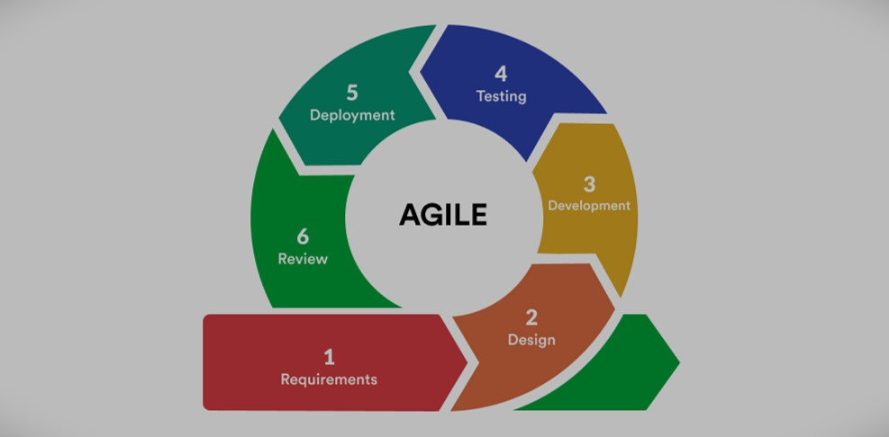
Figure 1: Agile Methodology

3.1.1Requirement Analysis
Requirement analysis is a critical phase in the development of an LMS, as it ensures the system meets the specific needs of the library and its users. This phase involves the gathering and analysis of functional and non-functional requirements, which outline what the system should do and the quality standards it must adhere to:

I Functional Requirements
Functional requirements outline the specific tasks that the system must perform to manage library effectively.
- Book Tracking and Management: The system should track real-time availability and status of books (e.g., title, author) and also allow addition, updating, and deletion of books The system should automatically update book status when issued, returned.

- User Management and Access Control: The system should Manage user accounts with role-based access (admin,user) as well as monitor user borrowing history, fines, and account status.
- Book Borrowing and Returning: The system should facilitate efficient book borrowing and returning processes and track due dates and overdue books automatically as well as provide notifications for overdue books and fines..
- Reporting and Analytics: The system should generate reports on book circulation (borrowed and returned), popular books, and user activity.
- Fine and Penalty Management: The system should automatically calculate fines based on overdue duration as well as track and generate reports on outstanding fines.
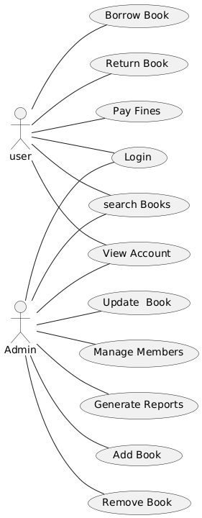
Figure 2: Use-Case Diagram

ii Non-functional Requirements
These are the performance and quality attributes that the system must meet to ensure usability, reliability, and scalability.
• Performance: The system should respond quickly to user actions, with book searches, updates, and transactions processed within seconds. It must handle a large number of users and transactions without performance degradation.
• Scalability: The system must be scalable to accommodate a growing number of books, users, and transactions as the library expands.
• Usability: The user interface should be intuitive, simple, and require minimal training for users to navigate and use efficiently. Both administrators and members should be able to use the system.
• Security: The system must enforce strong authentication protocols (e.g., username, password) to protect sensitive data. User access must be controlled based on roles (e.g., admin, user), ensuring the right level of access to data and functionality.
• Maintainability: The system should be easy to maintain, enabling regular updates, bug fixes, and feature enhancements without disrupting operations. Documentation should be available for both users and developers for maintenance tasks.
• Compliance: The system must comply with relevant industry standards, including those related to data protection, user privacy, and library management practices.

iii Technical Requirements
Technical requirements specify the hardware, software, and system environment needed for the system to function.
- Hardware Requirements: The system should run on standard server hardware or cloud infrastructure, with provisions for scalable storage and processing power.
- Software Requirements: The system should be developed using a backend (e.g. PHP) and a user-friendly frontend. It must use a reliable database system such as MySQL to store and manage data.
- Platform Compatibility: The system should be accessible via modern web browsers (e.g., Chrome).
- Backup and Recovery: The system must provide automatic daily backups with secure storage and easy recovery options in case of data corruption or loss.

3.1.2Feasibility Analysis
For our project we have done following feasibility study:

i Technical Feasibility
The technical feasibility of the Library Management System (LMS) ensures the system's compatibility with the library's existing hardware and software. It evaluates whether the current infrastructure, such as computers and printers, can support the new system. Additionally, the LMS must be scalable to handle growing collections, user volumes, and peak usage. Data security measures, including role-based access control and encryption, must protect sensitive information. The system should integrate smoothly with other tools and external services, such as cataloging systems and payment gateways. Overall, the LMS should be secure, scalable, easy to maintain, and compatible with the library's infrastructure.

ii Operational Feasibility
Operational feasibility of the Library Management System (LMS) focuses on how effectively the system can integrate into the library's day-to-day operations. The LMS should streamline processes such as book tracking, user management, borrowing and returning procedures, and fine calculation, replacing manual tasks and minimizing errors. The system must be intuitive and user-friendly to ensure easy adoption by library staff and users, with clear interfaces and minimal disruption to daily workflows. Training requirements should be minimal, with the LMS designed to be easy to use, though ongoing training may be necessary as new features are introduced. The system's reliability and uptime are crucial, as downtime could disrupt library services. An operationally feasible LMS will enhance efficiency, simplify tasks, and integrate seamlessly into the library’s existing operations.

iii Economic Feasibility
Economic feasibility of the Library Management System (LMS) evaluates the costs associated with the implementation and maintenance of the system, along with its potential financial benefits. Initial costs include software licenses, hardware upgrades (e.g.computers), installation, and customization.The economic analysis should also factor in the expected return on investment (ROI). The LMS can lead to cost savings through reduced labor, as automated processes (such as book tracking, due date reminders, and fine calculations) replace manual tasks. Additionally, improved inventory management (accurate book tracking and automatic updates) reduces errors and minimizes the need for physical checks, saving both time and resources. Furthermore, operational efficiencies, such as faster book checkout and return processes, can enhance user satisfaction, potentially increasing library usage and revenue. A break-even analysis can help determine how quickly the LMS will recover its costs through operational savings. In conclusion, an economically feasible LMS should provide long-term savings, a positive ROI, and be a worthwhile investment for the library.
iv Schedule
Task | Start Date | End  Date | Week 1 | Week 2-  3 | Week 4-  5 | Week 6-  9 | Week 10-11 | Week 12
Planning | 1- sept | 20-sept
Analysis | 20-sept | 5-oct
Design | 5-oct | 19-oct
Coding | 19-oct | 20-nov
Testing | 20-nov | 28-nov
Documentation | 2-sept | 11-jan
Delivery

Figure 3: Gantt Charts
    - Data Modeling (ER- Diagram)
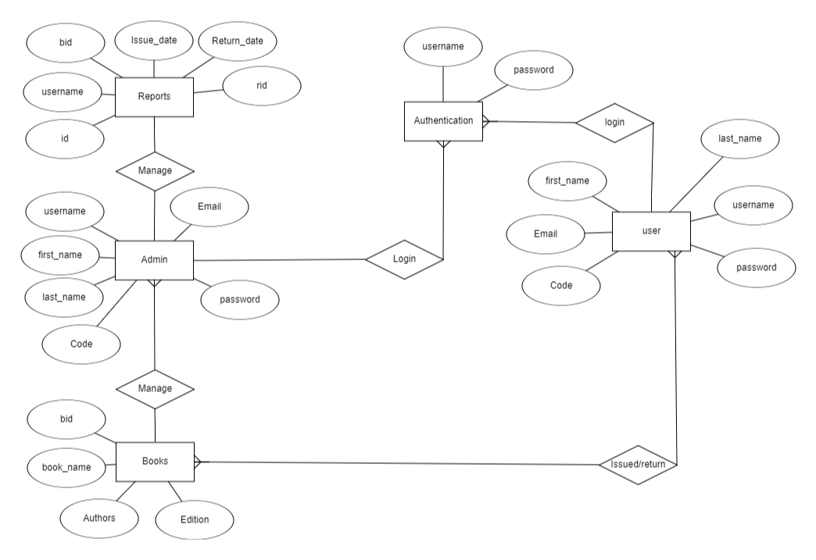
Figure 4: ER-Diagram

    - Process Modeling (DFD)
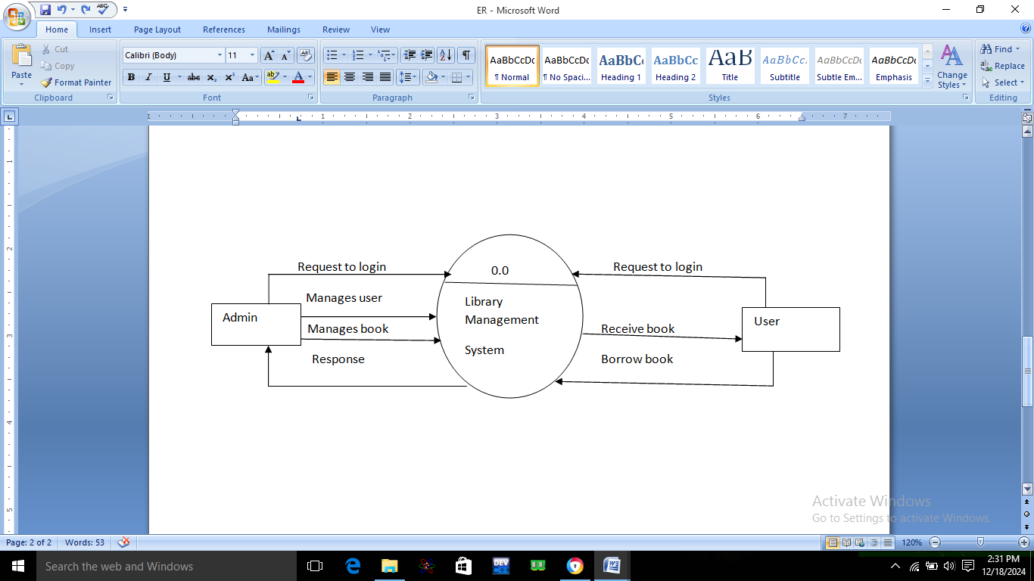
Figure 5: Process Modeling (DFD)

3.2 System Design
3.2.1 Architectural Design

Dashboard
Frontend Application

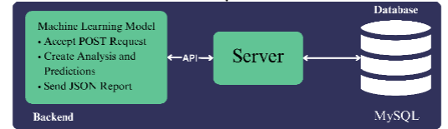

Server

Figure 6: Architectural Design

3.2.2 Database Schema Design
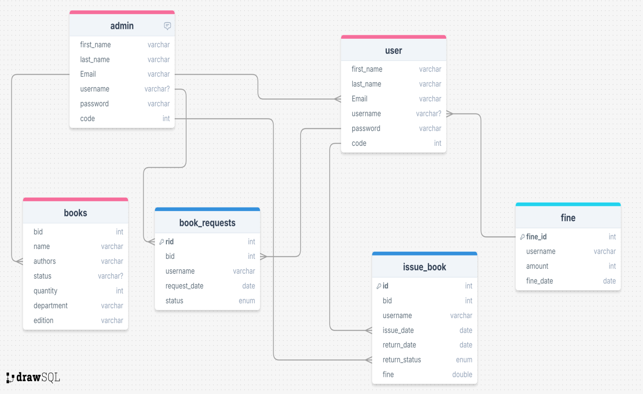

Figure 7: Database Schema Design of Library Management System
3.2.2 Interface Design
Library Management System

Book management Page
Items Page
Login Page

Redirect to Admin/User Search,Add delete new book View book

Dashboard request book

Figure 8: Interface Design of Library Management System

Chapter 4: Implementation and Testing
4.1 Implementation
During the implementation phase of Project Libraray Management System, a combination of programming language, frameworks and development tools were utilized to create a comprehensive and user-friendly system.
4.1.1 Tools Used
1. Programming Language:
a. PHP : PHP was chosen as the frontend programming language due
to its versatility and extensive libraries for web development.
2.Framework:
a. HTML and CSS : Html and Css was used to build the frontend
web application, providing tools and libraries for handling requests, routing,
and creating APIs.
3.Database Management System:
- MySQL: MySQL was used to store and manage structured data efficiently, facilitating easy retrieval and storage of items and related information.
4.Version Control:
- Git: Git facilitated version tracking, collaboration among team members, and code management.
5. Frontend Development:
- HTML, CSS, PHP : These core web technologies were used for creating the frontend user interface, ensuring responsiveness and interactivity.
- Bootstrap: Bootstrap provides a consistent and responsive design framework, expediting the creation of visually appealing web pages.
7. Text Editor:
- Visual Studio Code: Visual Studio Code offered a feature-rich development environment with extension for react and web development.

8. Diagram:
a. Plantuml(for creating database relationship diagrams): Plantuml allowed for the easy creation of clear and visual representation of database relationships.

4.2 Testing
Testing is the process of determining whether the system works effectively and efficiently. Testing does not only include debugging. It also checks for quality assurance, validation and verification, reliability and availability estimation. Testing can be done indifferent levels.
4.2.1 Test cases for Unit Testing
The unit testing part of testing methodology is the testing of individual software modules or components that make up a web application or system.
Table 1: Login Page Test Case
SN | Action | Input | Expected  Outcome | Actual  Outcomes | Test  Result
1 | On Submit | Null | Enter Your  Credential | Enter Your  Credential | Fail
2 | Enter username  and Password | Roji  Roji10 | Redirect to  dashboard | Redirect to  dashboard | Pass

SN | Action | Input | Expected Outcomes | Actual Outcomes | Test status
1 | Null Submit | NULL | Exception raise | All fields are required | PASS
2 | Submit without  First name and last name | No first name and last name | Incomplete  Submission | First name and last name  Required | FAIL
3 | Submit Without  Username | No Username | Incomplete  Submission | Username  Required | FAIL
4 | Submit without  password | NO password | Incomplete  Submission | Password Required | FAIL
5 | Submit without  Email | NO Email | Incomplete  Submission | Email  Required | FAIL
6 | Submit without  Code | No code | Incomplete  Submission | Code Required | FAIL
7 | Submit with all  Requirements | First name, last name ,username,  Password,  Email, code Submitted | Successful  Submission | Successful | PASS

Table 2: Registration test case

4.2.2 Test Case for System Testing
The overall testing of the system after integrating all the project’s functions is known as system testing.
SN | Action | Input | Expected Outcome | Actual Outcome | Status
1 | Book | Name | Name | Book | PASS
2 | Add Book | No Name | Error | Enter Name | FAIL

Table 3: System Testing

Chapter 5:Conclusion and Future Recommendations

5.1 Outcomes

Through the development of the Library Management System (LMS), valuable lessons were learned that shaped the project's direction and contributed to its success. Defining a clear project scope, embracing Agile methodologies for adaptability, and ensuring effective communication were key to achieving project goals. The process involved thorough testing plans, continuous collaboration, and a focus on identifying and resolving issues early, ensuring a smoother development cycle.

The outcomes of the project include a functional and scalable Library Management System, with features such as user management, book tracking, borrowing and returning processes, and fine management Additionally, the LMS provides a contribution to improving library management and facilitating easier book tracking and user interaction.

5.2 Conclusion

In conclusion, completing the project “Library management system ” represents a significant milestone in the libraries. The successful development of library system makes a positive impact on book management. Through the collaborative efforts of the team, the project achieved its objectives, delivering a functional and user-friendly interface that enables users to update, delete and manage the book records. The project’s adherence to Agile methodologies demonstrated the value of iterative development and continuous improvement, resulting in a robust and adaptable solution. This endeavor not only depends on our technical skill in web development and project management but also reinforced the importance of effective communication, teamwork, and problem solving. As project “Library management system ” contributes to school and college libraries and enhances our understanding of complex technologies, it stands as testament to innovation, collaboration, and the potential to positively impact lives through technology-driven advancement in book management.

5.3 Future Recommendations
1 Digitization and Automation
- Cloud-Based Solutions: Transition to cloud-based LMS for real-time access, scalability, and secure remote management of library operations.
- Automation Technologies: Integrate barcode scanning, RFID (Radio Frequency Identification), and IoT devices to automate book tracking, reduce manual efforts, and improve accuracy.
2 Predictive Analytics and AI
- Demand Forecasting: Use AI-powered analytics to predict book demand, helping libraries manage acquisitions efficiently based on borrowing patterns and seasonal needs.
3 Mobile-Friendly Solutions
- Mobile Apps: Develop mobile applications for library users to search catalogs, reserve books, and track borrowing history on the go.
- Offline Mode: Implement offline features for seamless access to library resources in areas with limited or inconsistent internet connectivity.
4 Support for Local Innovation
- Collaboration with Startups: Partner with local developers and startups to design customized LMS tools addressing specific challenges faced by libraries in Nepal, promoting innovation and sustainability.

Appendices
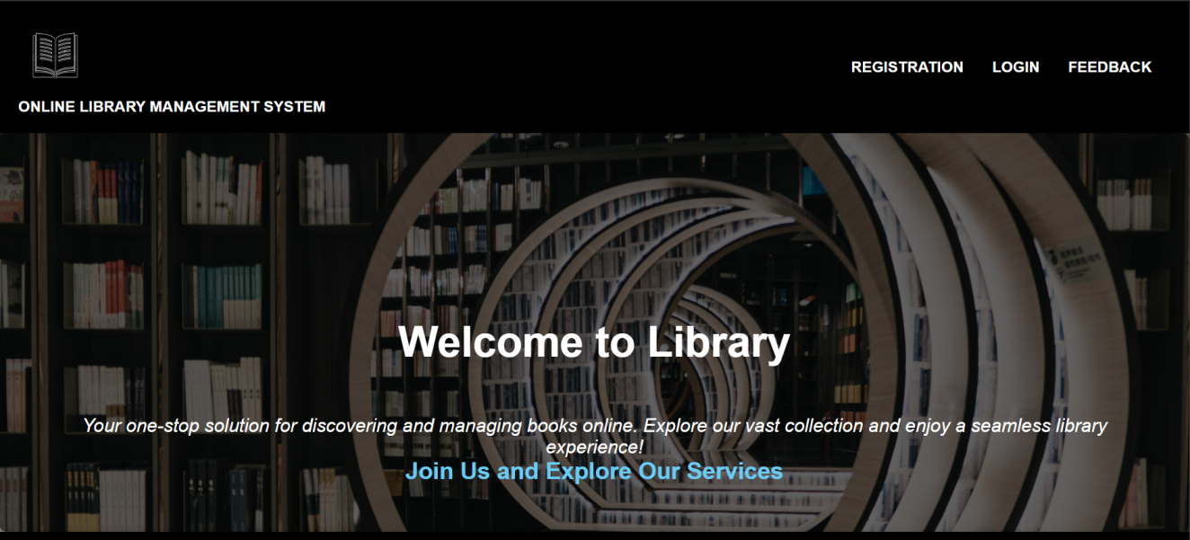
Fig: Home page
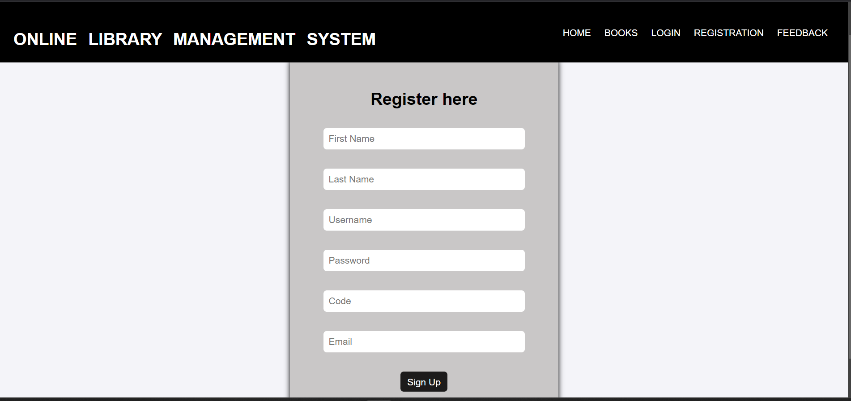
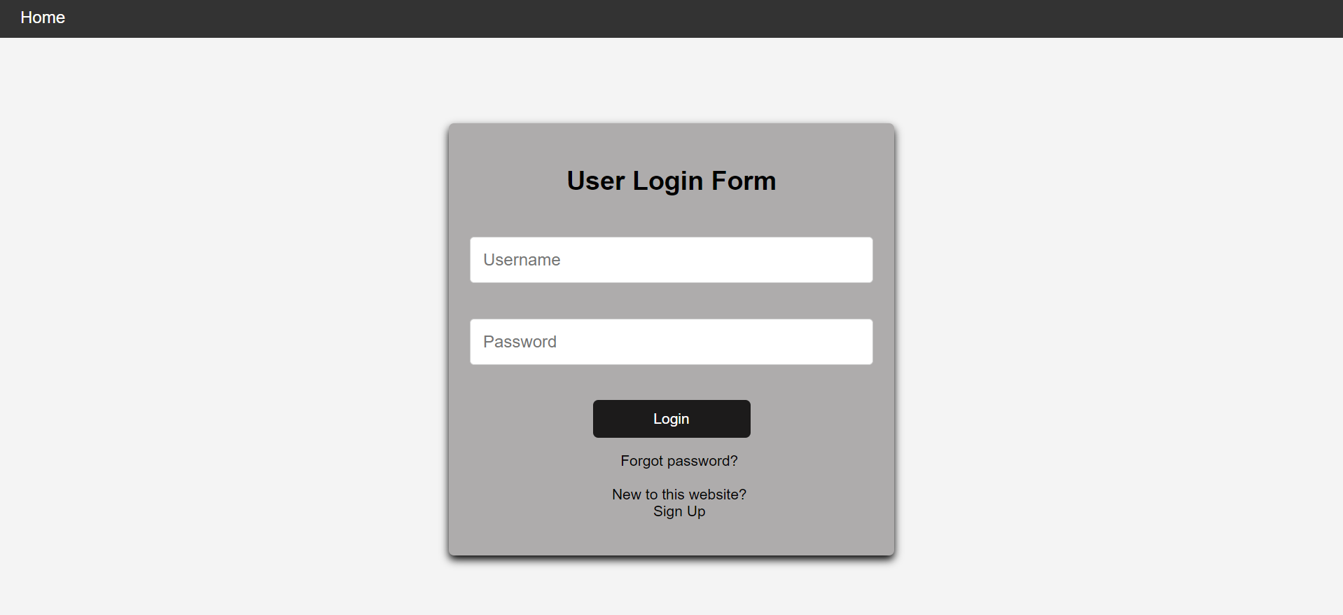
Fig: Registration page

Fig: Login page
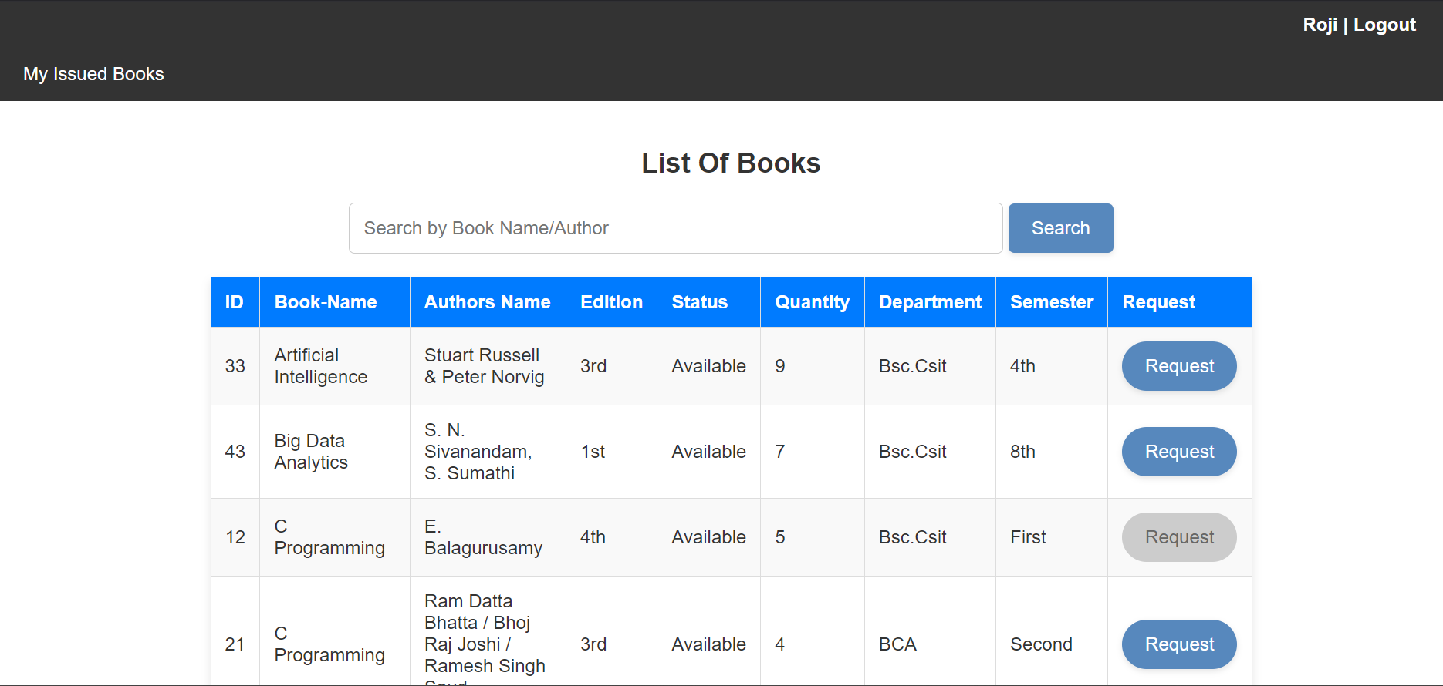
Fig: list of book page ( user)
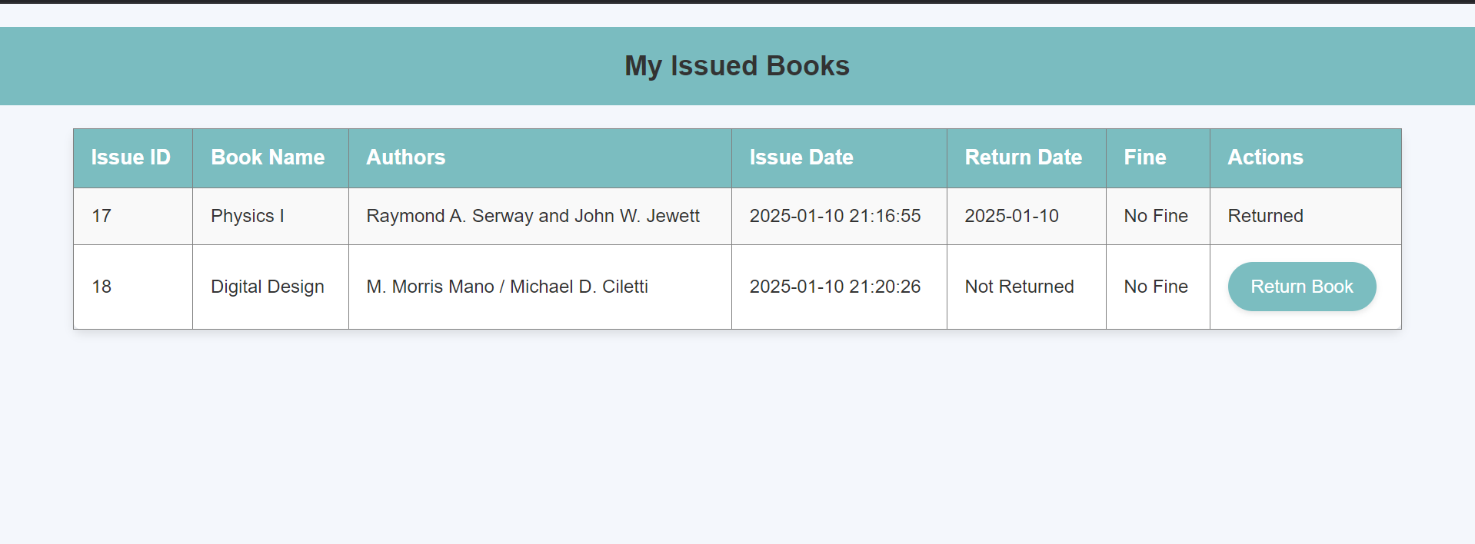
Fig: Issued book page (user)
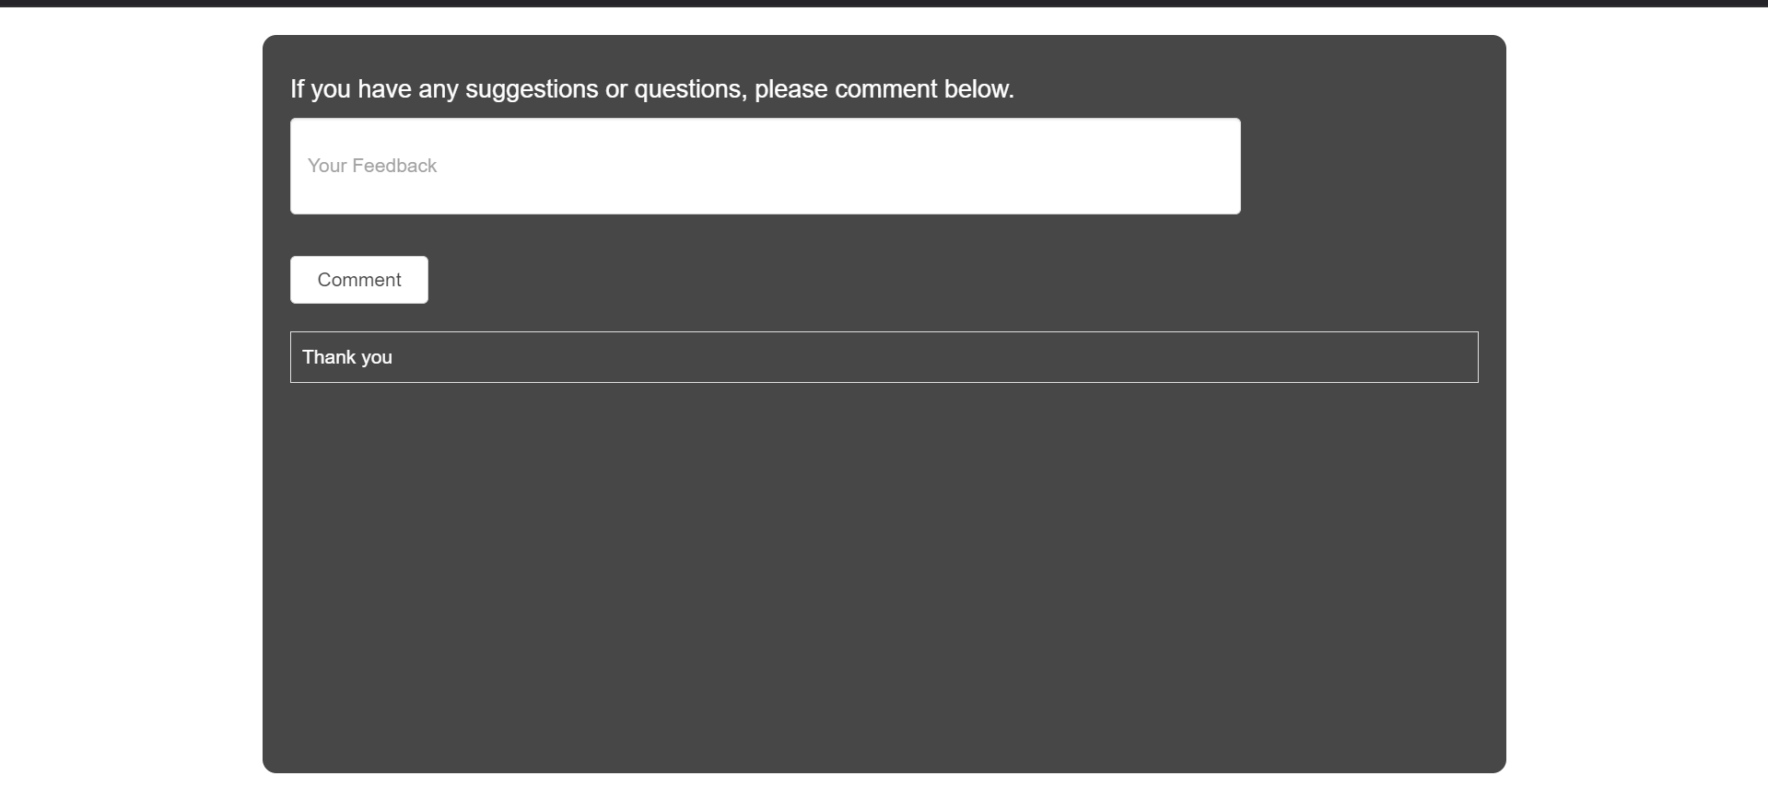
Fig: feedback page
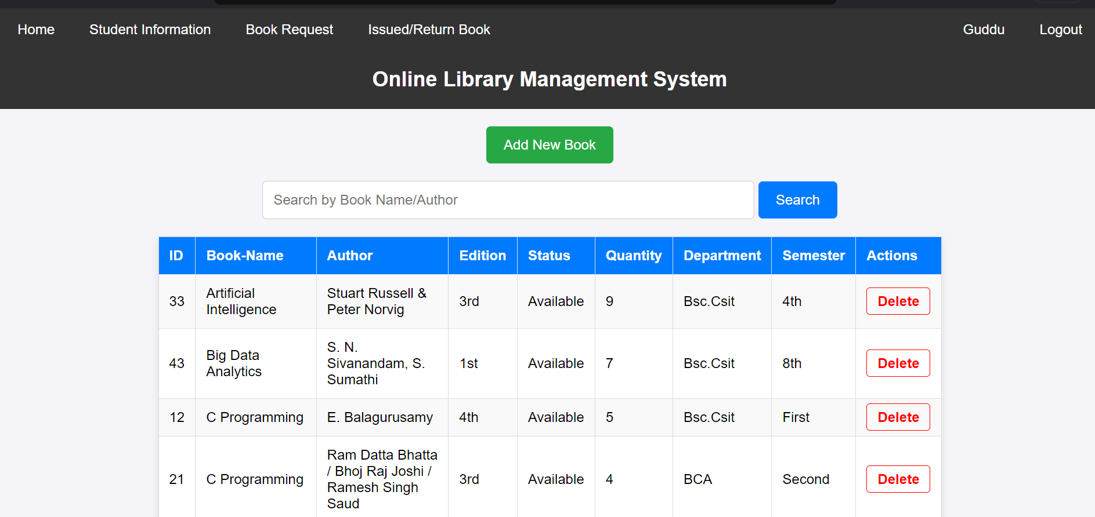
Book management page(admin)
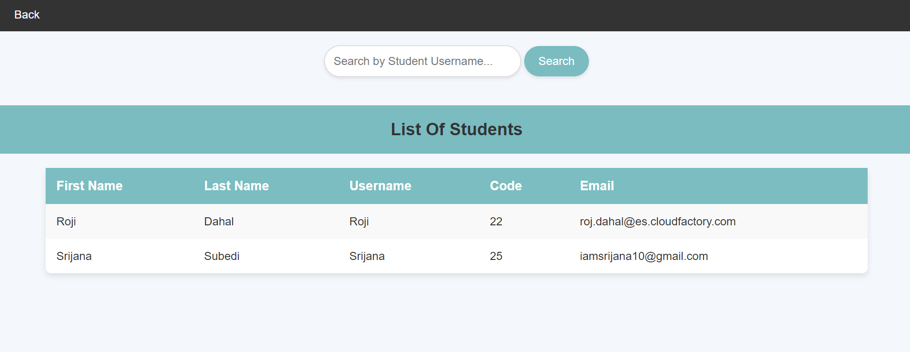
Fig: Student details (admin)
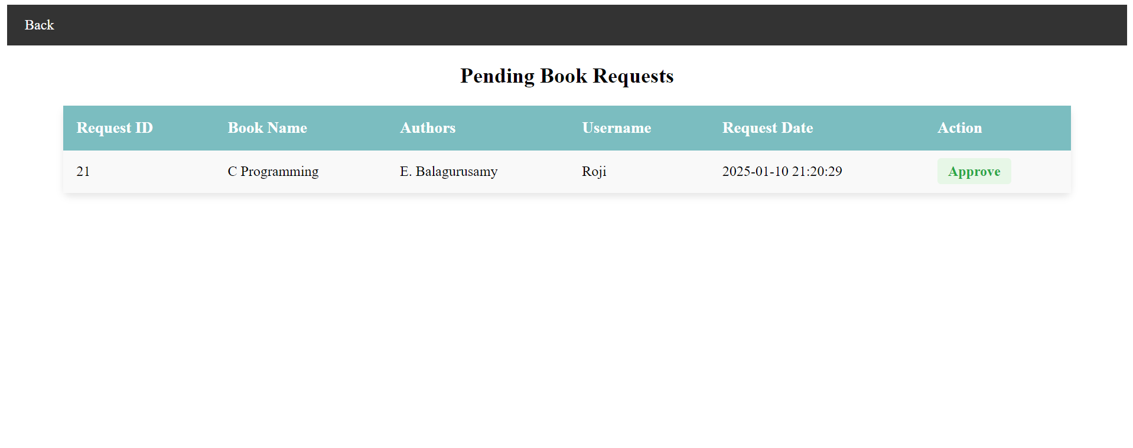
Fig: manage book request(admin)
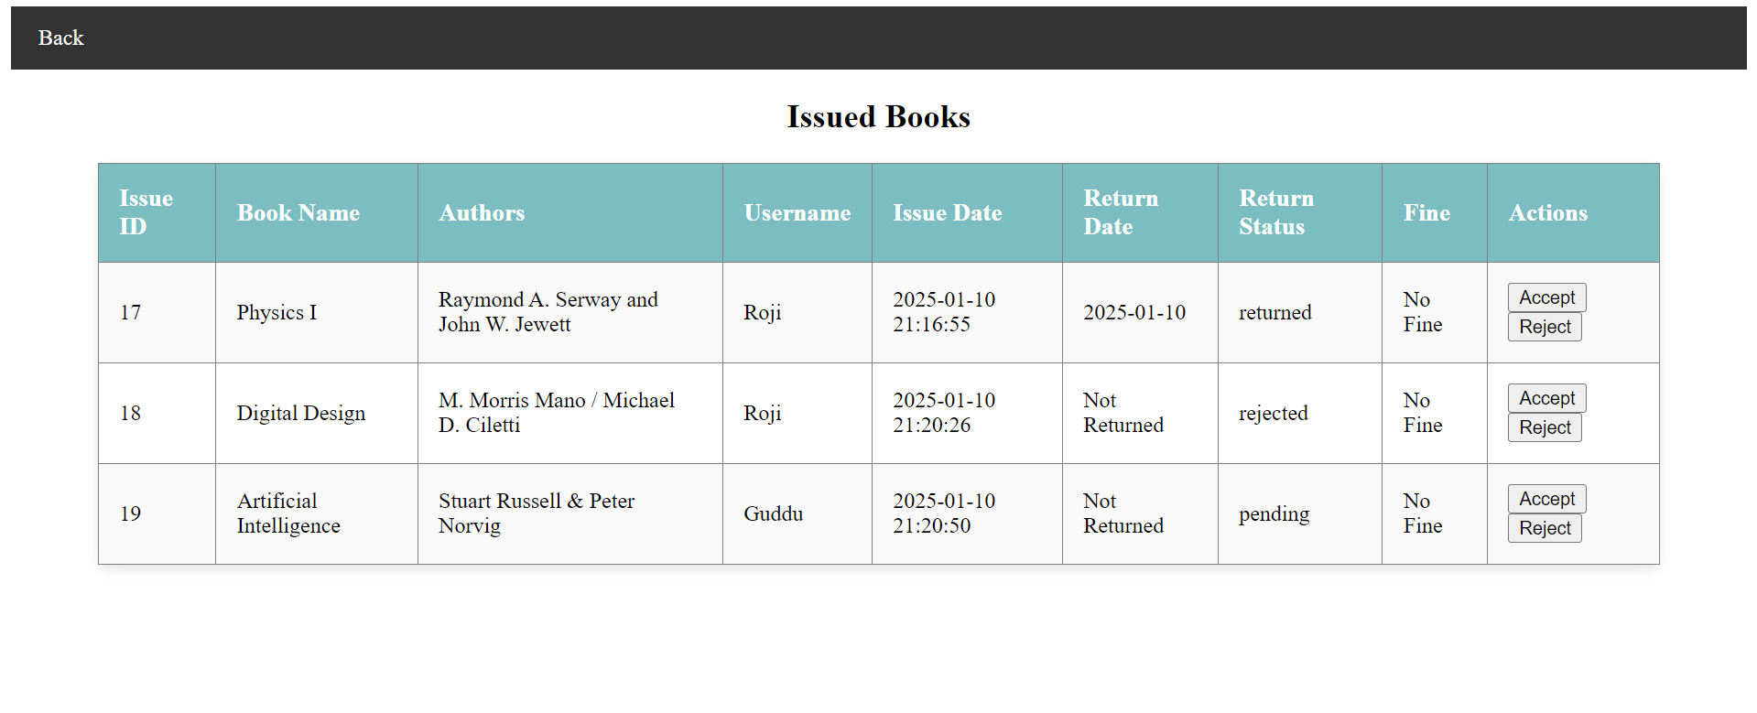

References

[1] | R. Sharma, R. Bansal, and P. Kumari, "Library Management System: A Web-based Approach," International Journal of Computer Applications, pp. 45-49, 2017.
[3] | M. S. Gurung, "The Role of Library Management Systems in Enhancing Educational Resources in Nepal," Journal of Educational Technology and Library Science, pp. 58-64, 2022.

